trend

General

Community

Human Behaviour

Nature
Strength

Weakness unconfidence

learn Avoid

observe

hear
inner world of others failure reason of others

Imitation

Creativity
Try

imagine

by age limitation

reality

give up ridiculars thoughts unconstrained

think taste smell
unreal

Know the World

last feeling

Learning Ability

Know yourself

educate
focus on

waste time
practical courses art
music handmade

experience

reading
understand truth
lessons from others Judge & Classify

Complicated life
frustration happiness fluctuate

Different people
Archiving Management
improve

self-improvement
get along

learn

switch another ways

our behaviour
No same people

Uniqueness
Learn from mistakes
seek wiser methods

other channels

unknown

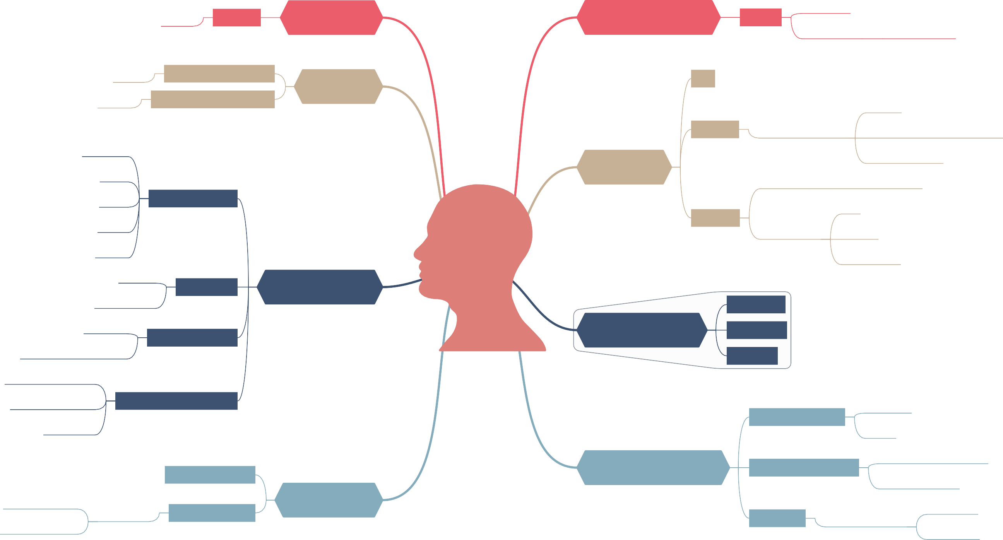
others attitude
influence
mental process
obstinacy
poorly effective

inertness

