Tip 1

Sub Topic Sub Topic

Sub Topic Sub Topic

Sub Topic

Sub Topic

Sub Topic

Sub Topic

Sub Topic
Threat 4
Tips
Tip 3

Threat
Threat 3
Strength
Threat 2
Threat 1
Tip 2

SWOT analysis

Sub Topic

Sub Topic
Strength 1

Sub Topic

Sub Topic Sub Topic
Opportunity 1
Strength 3
Strength 2

Sub Topic

Sub Topic

Sub Topic

Sub Topic Sub Topic Sub Topic

Sub Topic Sub Topic

Sub Topic
Sub Topic Sub Topic

Sub Topic Sub Topic Sub Topic Sub Topic
Summary
Opportunity 2

Opportunity

Sub Topic Sub Topic
8/1 - 8/30 : 1.0 Month
Opportunity 3
Opportunity 4
Strength 4

Need to be improved
Gloria Team
Weakness 1

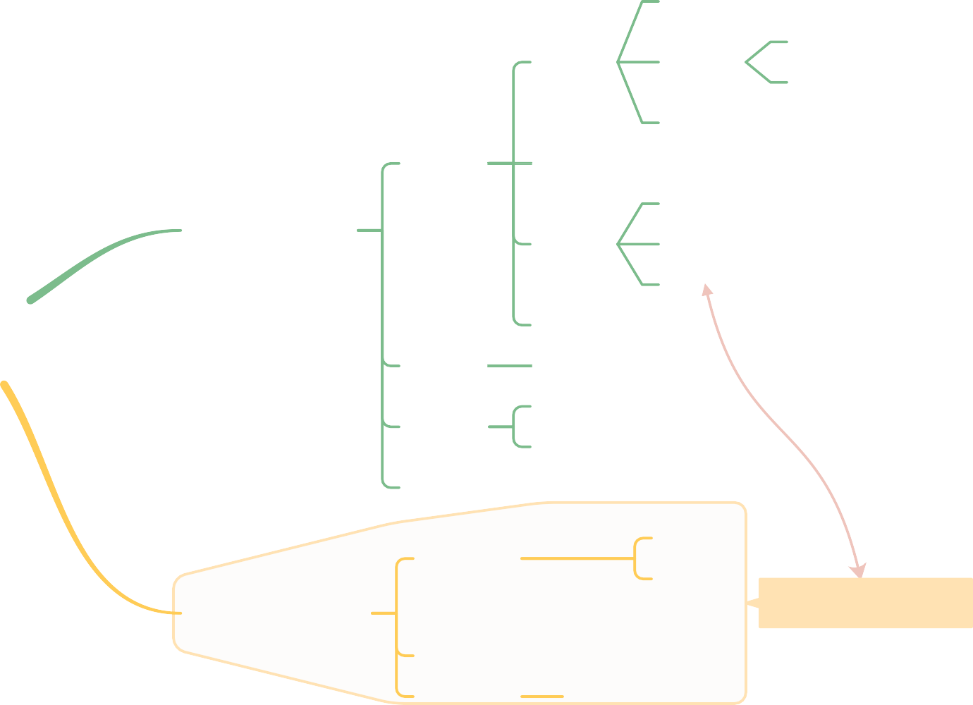Sub Topic
Weakness 2
Weakness
Sub Topic
Weakness 3

