Black Spider

Black
Red
Red Car

White Snowflake

White
Yellow
Yellow Duck

Brwon Bear

Brown

Color

Blue
Blue Envelope

Purple Grapes

Purple
Green
Green Tree

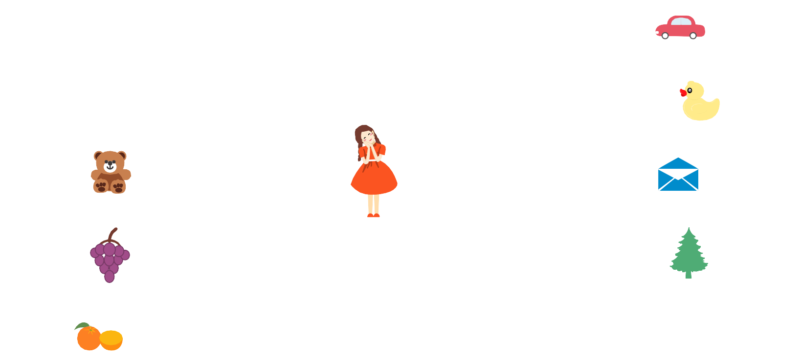Orange

Orange
Gray
Gray Cap

