By Peter Drucker First version in 1966
Avoiding unproductive factors

The Effective Executive Zero to One
By Peter Thiel
First version in 2014 Venture capitalist

By Clayton M. Christensen Fisrt version in 1997
S-Curve Disruptive technologies Resources dependence

The Innovator's Dilemma

Reality Check
By Peter Abrahams First version in 2009 Young adult fiction Won the Edgar Award

Declaration of independence High moral standards

Benjamin Franklin

Top 10 Recommended Books for Entrepreneurs

Out of the Crisis
By W. Edwards Deming First version in 1986
Transform management style Based on specific skills

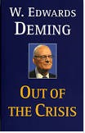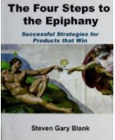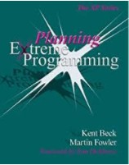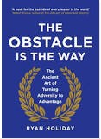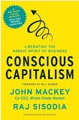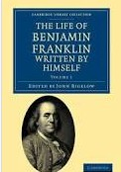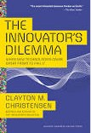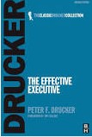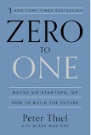By John Mackey First version in 2012
A defense of capitalism New way of doing business

By Ryan Holiday First version in 2014
Roman philosophy of stoicism

Conscious Capitalism

The Obstacle Is the Way

The Four Steps to the Epiphany

Extreme Programming Explained
By Steve Blank
First version in 2005 Bring products to market

By Kent Beck
First version in 1999
Software development requirements

