Now Target When How

ATTITUDE

CAREER
Now Target When How

Target When How

Now Target When How

EDUCATION

PUBLIC SERVICE

Goal Setting

HEALTH

WEALTH
Body Mental Spiritual

Now Target When How

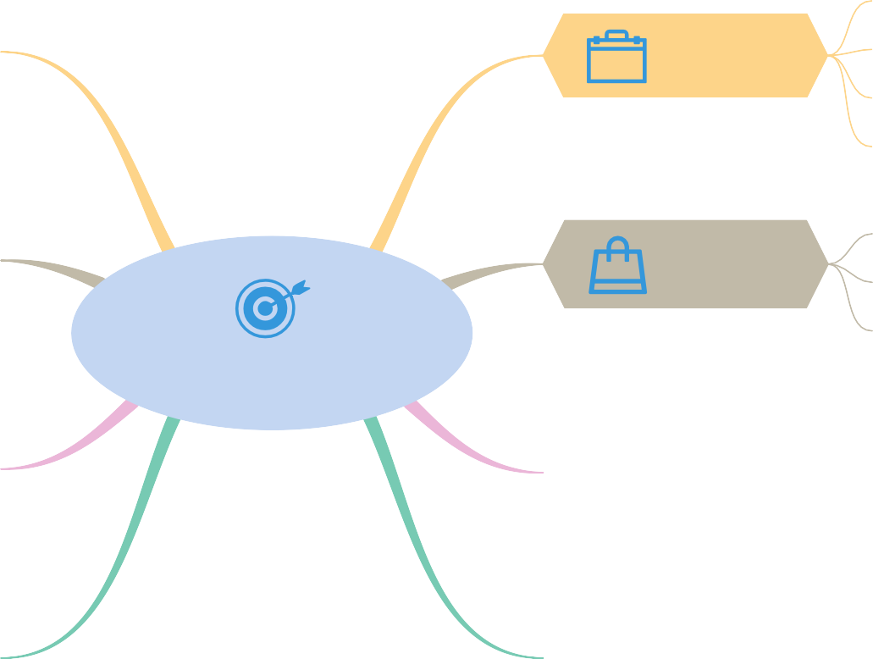Hobbies
Skills
PERSONAL GROWTH

RELATIONSHIPS
Family Friends

