Digg Reddit Quora

Social Bookmark

Blogging

Blogger Medium Wordpress

Flickr Pinterest

Google Plus
Photo Sharing Social Network

Social Media Uses

Facebook My Space

LinkedIn
Business Social
Video Sharing
YouTube

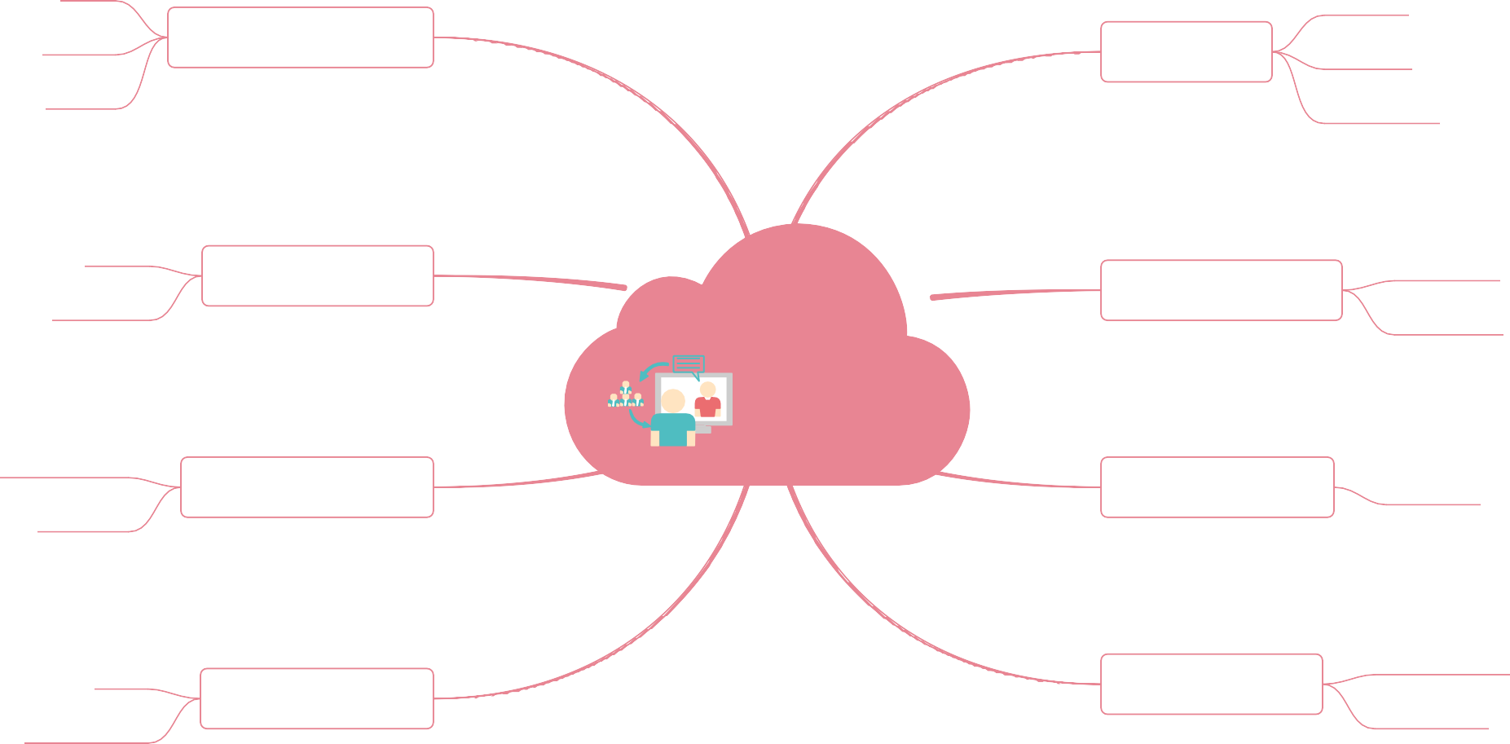Yelp City Search

User Reviews

Collaborating
Google Docs Basecamp

