Zoography
Descriptive zoology
The analysis of habitats

Belongs to Biology
Embryology
Comparative Anatomy
The structure of animals

Classifications of animals
Living and extinct
Ecosystems Come from Greece

General Concepts

Ethology
The analysis of animals' behaviors Behaviourism

Natural history Aristotle and Galen Muslim physicians

Zoology
Behavioral Ecology
Ecological pressures

William Harvey Cell theory
Mechanical philosophy
Scientific subjects

Ancient

History
Soil Zoology
Soil fauna
Came from the UK

Common genetic

The mutability of animals Charles Darwin
Molecular Biology
Developmental mechamisms

Morphology Spontaneous generations
Recent times

Evolutionary Biology

Population genetics Mendelism

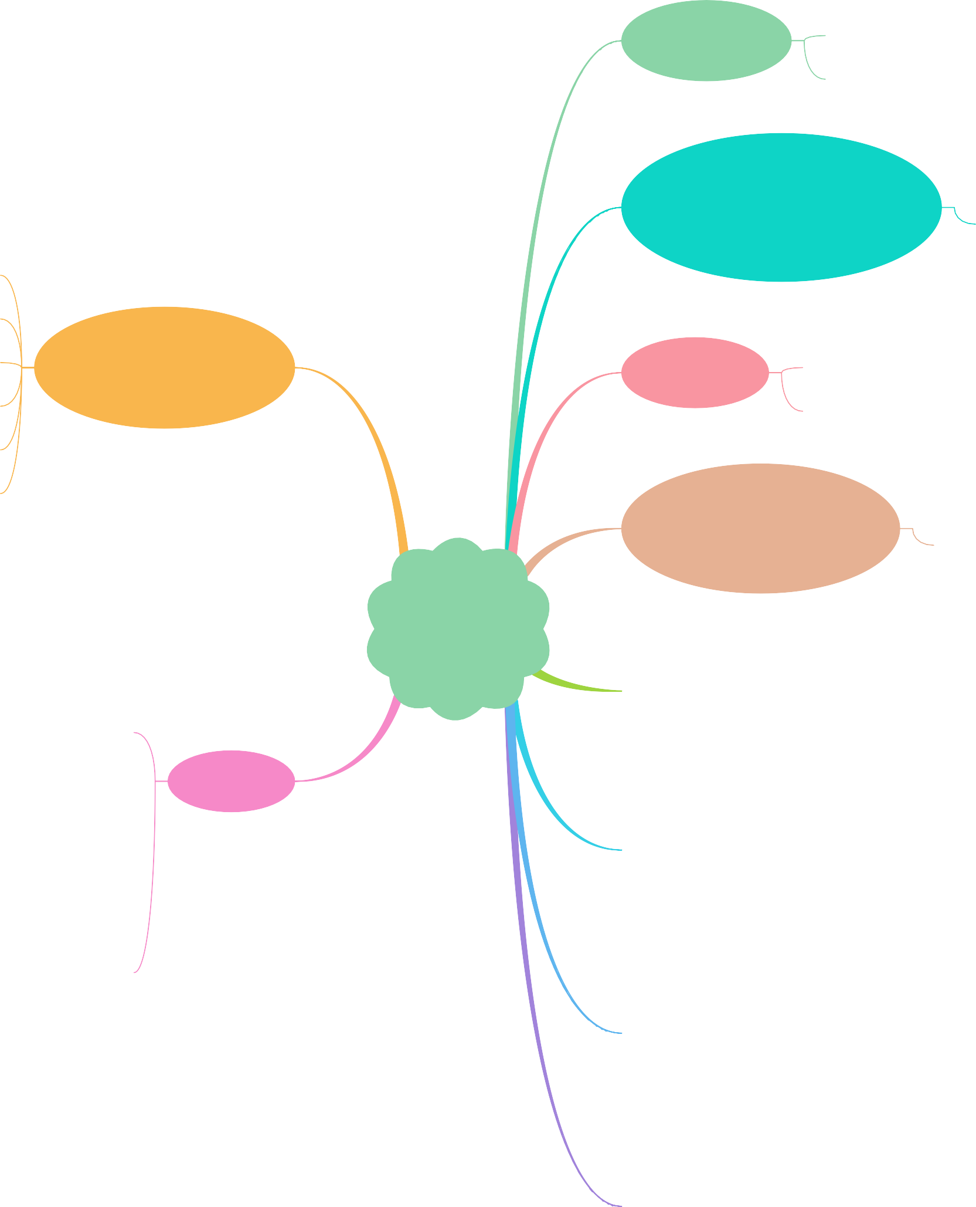

Palaeontology

